Group 8:
s3500286 - Nguyen Thanh Duc
s3500291 - Nguyen Dang Tuan
s3410417 - Tran Minh Quang
Game: Mole Frenzy

- Introduction
There are two things we encountered while developing this Android game that we would like to share in this document.

- Spawning Moles algorithm:
We thought of two ways to have a mole appears from the hole. The first way is having the hole creates a mole every time its timer is up, then the mole will be destroyed when it is hit or when it goes down. The second way is to have the mole hides under the hole, when the timer is up, the hole goes up and then it goes down into hiding without having to create or destroy objects. We choose the second method.

- Artificial Intelligent (AI):
We did some research on the AI for the classic game Whack-A-Mole, but we could not find anything. We also downloaded a few Whack-A-Mole games that is currently on Google Store. But none of them have AI. So we decided to developed our own AI.

- Advantages and disadvantages
1. Spawning Moles algorithm:
Advantages:
- The game does not need to create and destroy objects.

Disadvantages:
- This is just a speculation. We do not know if the game renders the moles hiding under the hole or not. We do not know if creating and destroying objects use more resources than keeping the moles hiding.

2. Artificial Intelligent (AI):
Advantages:
- Can change the behaviour of the AI easily.
- Can add and remove holes, moles and type of moles in the game and change the AI to recognize them.

Disadvantages:
- It only works with the our game setup (read Spawning Moles algorithm to understand our game setup).

- Requirements
There is no strict requirement, these algorithms can probably be replicated by other engines and languages. Just a reminder that our game is developed with Unity engine and the codes are written in C#.

- Steps and Screenshots
1. Spawning Moles algorithm
We choose to have all the moles of all types hide under the hole. They will go up whenever the timer is up and go down into hiding again when they are hit.
There are 12 holes and 3 types of mole, the total number of moles is 36 and each hole has 3 moles hiding under it. Whenever a mole comes up from a hole, it locks the hole and prevent the other moles from coming up. Thus, only one mole can appear on the hole at a time. For the bonus mole, the bonus mole will appear on a timer (currently 10 seconds). When the timer is up, the game will generate a random number from 0 - 11 (the number of holes), then the bonus mole will appear at that hole and locks the other mole types from coming up. Below is a screenshot of things that hide underground.

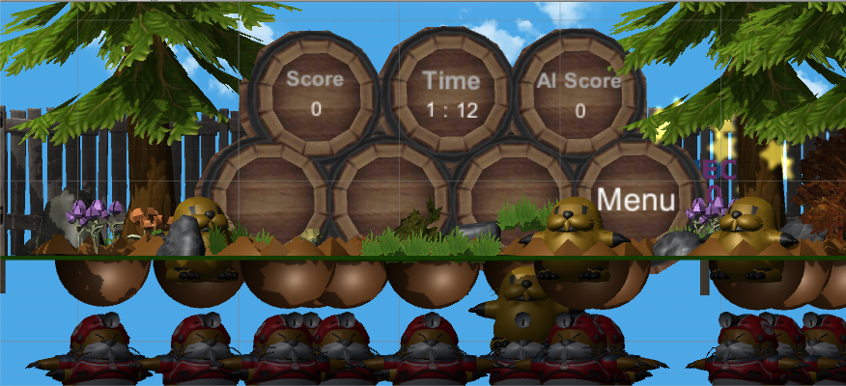

2. Artificial Intelligent (AI)
There are 3 arrays: one array to store the holes, one array to store the check result, and one double dimension array to store all the moles. Because each hole has 3 moles, so the array moles[0] = {normalMole0, minusMole0, bonusMole0} (this is just an example, Unity has a better method to find game objects).
Whenever the AI timer is up, there are two things that the AI is going to do to determine where it is going to hit next.
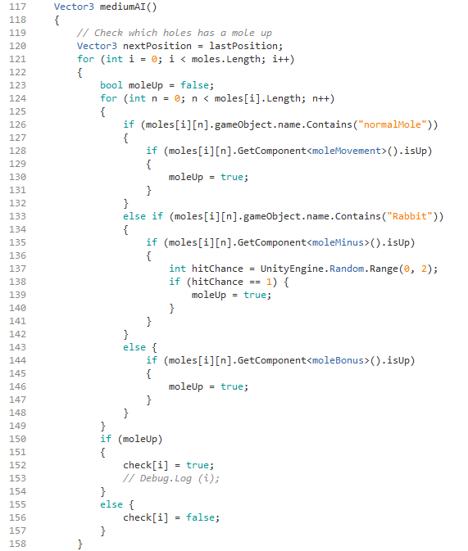
First, the AI will check which hole has a mole showing up. The AI will check the double dimensional array and check all the moles’ value isUP, which return boolean. If one of the three moles returns true, value moleUp becomes true. Regardless, the AI will record those boolean results to the check array. For the minus mole, the chance that a medium AI to detect it is 50%, for hard is 25%. Below is the code for this part, note that this is the code for level medium.

Second, using the check array, the AI will get the hole’s position from the hole array. It then calculates the distance from the holes to its current position using Pythagorean Theorem. The AI will choose the nearest hole to hit next.
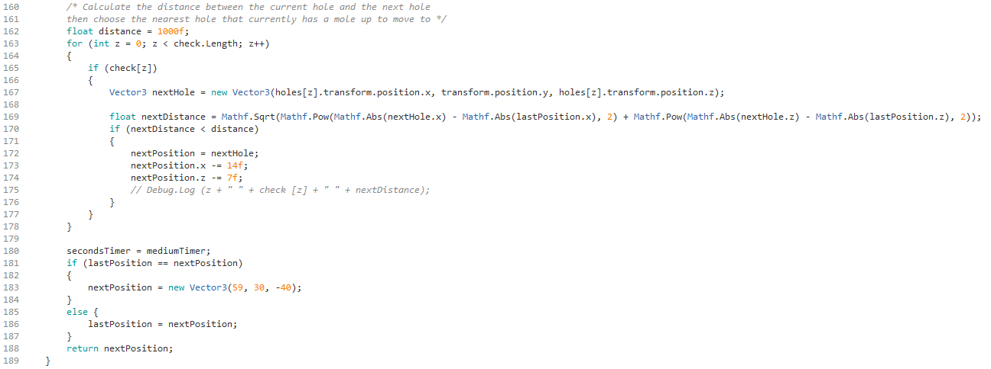
The differences between levels of AI:
- Easy: There is no AI.
- Medium: the AI uses the above algorithm.
- Hard: the AI uses the above algorithm with a shorter waiting time than Medium AI and only 25% to detect the minus mole.

- References

Unity engine:
https://unity3d.com/

Parse:
https://parse.com/

3D Models:

Monty Mole by John2k4 from the Models Resource
http://www.models-resource.com/wii/marioparty9/model/4230/

Monty Mole by Previous from the Models Resource
http://www.models-resource.com/wii/mariostrikerscharged/model/5779/

White Rabbit by Roxas358 from The Models Resource
http://www.models-resource.com/playstation_2/KingdomHearts/model/1802/

Kirby Effects by MightyJetters from the Models Resource
http://www.models-resource.com/wii/SuperSmashBrosBrawl/model/4466/

Resetti by thegameexplorer from The Models Resource
http://www.models-resource.com/wii/SuperSmashBrosBrawl/model/3800/

Other models and graphics are from Unity engine.

Music:
Mushroom Dance by bart from OpenGameArt.org
http://opengameart.org/content/mushroom-dance

Forest by syncopika from OpenGameArt.org
http://opengameart.org/content/forest

Puzzle Music by axtoncrolley from OpenGameArt.org
http://opengameart.org/content/puzzle-music-desert-meets-shore-theme

Relax_background1 by joaquinton from OpenGameArt.org
http://opengameart.org/content/relaxbackground1-0

